727721EUIT152
SOMA SUNDARI R
DAY 4
TASK 1:
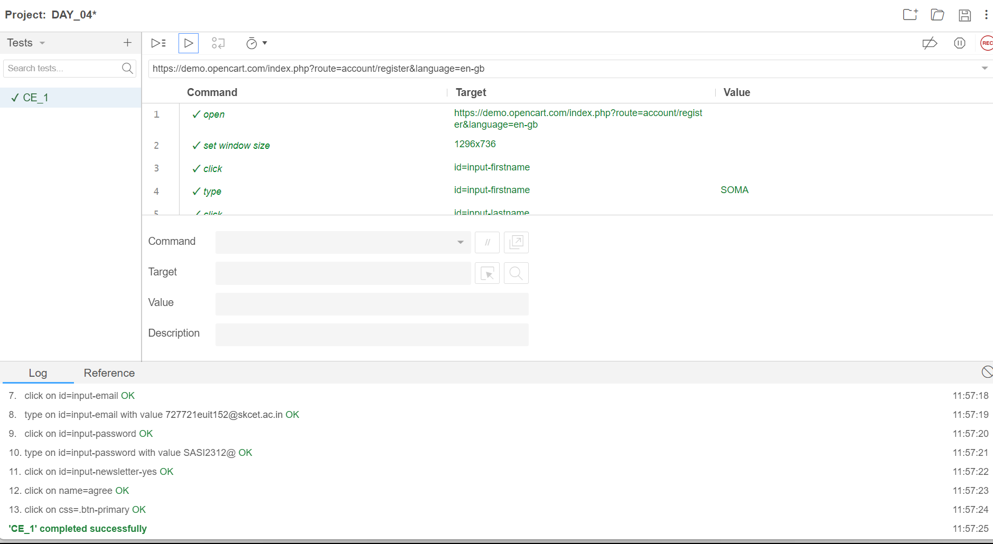

TASK 2:
package com.demo.demo;

import org.openqa.selenium.By;
import org.openqa.selenium.WebDriver;
import org.openqa.selenium.WebElement;
import org.openqa.selenium.chrome.ChromeDriver;
import org.openqa.selenium.chrome.ChromeOptions;

import io.github.bonigarcia.wdm.WebDriverManager;

public class CE02 {

public static void main(String[] args) throws InterruptedException {
// TODO Auto-generated method stub
ChromeOptions co=new ChromeOptions();
co.addArguments("--remote-allow-origins=*");
WebDriverManager.chromedriver().setup();
WebDriver driver=new ChromeDriver(co);
// driver.get("https://www.google.com/");
// CE 02
driver.navigate().to("https://demo.opencart.com/index.php?route=account/register&language=en-gb");
WebElement fname=driver.findElement(By.id("input-firstname"));
fname.sendKeys("SOMA SUNDARI");

WebElement lname=driver.findElement(By.id("input-lastname"));
lname.sendKeys("R");

WebElement email=driver.findElement(By.id("input-email"));
email.sendKeys("727721euit152@skcet.ac.in");

WebElement pass=driver.findElement(By.cssSelector("input#input-password"));
pass.sendKeys("skcet");

Thread.sleep(5000);
WebElement sub=driver.findElement(By.id("input-newsletter-yes"));
sub.click();
}

}

TASK 3:
package com.demo.demo;
import org.openqa.selenium.By;
import org.openqa.selenium.JavascriptExecutor;
import org.openqa.selenium.WebDriver;
import org.openqa.selenium.chrome.ChromeDriver;
import org.openqa.selenium.chrome.ChromeOptions;
import io.github.bonigarcia.wdm.WebDriverManager;
public class CE03 {
public static void main(String[] args) throws InterruptedException {
// TODO Auto-generated method stub
ChromeOptions co=new ChromeOptions();
co.addArguments("--remote-allow-origins=*");
WebDriverManager.chromedriver().setup();
WebDriver driver=new ChromeDriver(co);
driver.get("https://demo.opencart.com/index.php?route=checkout/voucher&language=en-gb");
driver.manage().window().maximize();
driver.findElement(By.xpath("//input[@id=\"input-to-name\"]")).sendKeys("Usha");
JavascriptExecutor js=(JavascriptExecutor) driver;
js.executeScript("window.scrollBy(0,500)","");
Thread.sleep(5000);
driver.findElement(By.xpath("//input[@id=\"input-theme-6\"]")).click();
}
}

TASK 4:
package com.demo.demo;

import org.openqa.selenium.By;
import org.openqa.selenium.JavascriptExecutor;
import org.openqa.selenium.WebDriver;
import org.openqa.selenium.chrome.ChromeDriver;
import org.openqa.selenium.chrome.ChromeOptions;

import io.github.bonigarcia.wdm.WebDriverManager;

public class CE04 {

public static void main( String[] args ) throws InterruptedException
{

ChromeOptions co=new ChromeOptions();
co.addArguments("--remote-allow-origins=*");
WebDriverManager.chromedriver().setup();
WebDriver driver=new ChromeDriver(co);
driver.get("https://j2store.net/free/");
driver.manage().window().maximize();
JavascriptExecutor js=(JavascriptExecutor) driver;
js.executeScript("window.scroll(0,1000)", "");
Thread.sleep(3000);
//

driver.findElement(By.xpath("/html/body/div[2]/div/div[2]/div/div/div/div/ul/li[1]/h4/a")).click();

driver.navigate().back();
driver.navigate().forward();
driver.navigate().refresh();
driver.close();

}
}
TASK 5.1:

package com.demo.demo;

import org.openqa.selenium.By;
import org.openqa.selenium.WebDriver;
import org.openqa.selenium.chrome.ChromeDriver;
import org.openqa.selenium.chrome.ChromeOptions;

import io.github.bonigarcia.wdm.WebDriverManager;

class CE05 {

public static void main(String[] args) {
// TODO Auto-generated method stub
ChromeOptions co=new ChromeOptions();
co.addArguments("--remote-allow-origins=*");
WebDriverManager.chromedriver().setup();
WebDriver driver=new ChromeDriver(co);
driver.get("https://j2store.net/free/");
driver.manage().window().maximize();
String currentUrl=driver.getCurrentUrl();
String expectedUrl="https://j2store.net/free/";
if(currentUrl.equals(expectedUrl)) {
System.out.println("URL Matched");
}
else {
System.out.println("URL not Matched");
}
driver.findElement(By.xpath("//*[@id=\"Mod112\"]/div/div/ul/li[1]/a")).click();
String CUrl=driver.getCurrentUrl();
String EUrl="https://j2store.net/free/index.php/shop?filter_catid=11";
if(CUrl.equals(EUrl))
{
System.out.println("URL MATCHED");
}
else
{
System.out.println("URL NOT MATCHED");
}
driver.close();

}
}
OUTPUT:

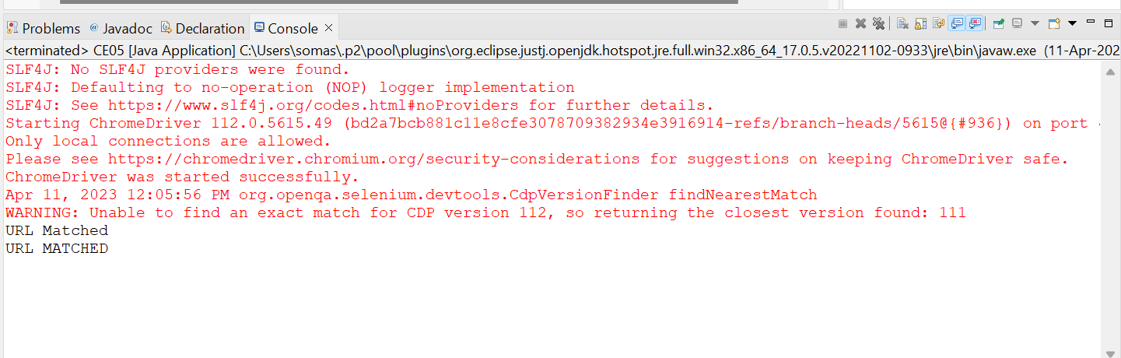

TASK 5.2:
package com.demo.demo;

import java.util.List;

import org.openqa.selenium.By;
import org.openqa.selenium.WebDriver;
import org.openqa.selenium.WebElement;
import org.openqa.selenium.chrome.ChromeDriver;
import org.openqa.selenium.chrome.ChromeOptions;

import io.github.bonigarcia.wdm.WebDriverManager;

public class CE05_2 {
public static void main( String[] args ) throws InterruptedException
{
ChromeOptions co=new ChromeOptions();
co.addArguments("--remote-allow-origins=*");
WebDriverManager.chromedriver().setup();
WebDriver driver=new ChromeDriver();
driver.get("https://j2store.net/free/");
driver.manage().window().maximize();
driver.findElement(By.xpath("/html/body/div[2]/div/div[2]/div/div/div/div/ul/li[1]/h4/a")).click();
Thread.sleep(3000);

List<WebElement> li=driver.findElements(By.xpath("//h2[@itemprop=\"name\"]"));

for (WebElement link:li) {
System.out.println(link.getText());
}
}
}

OUTPUT:

